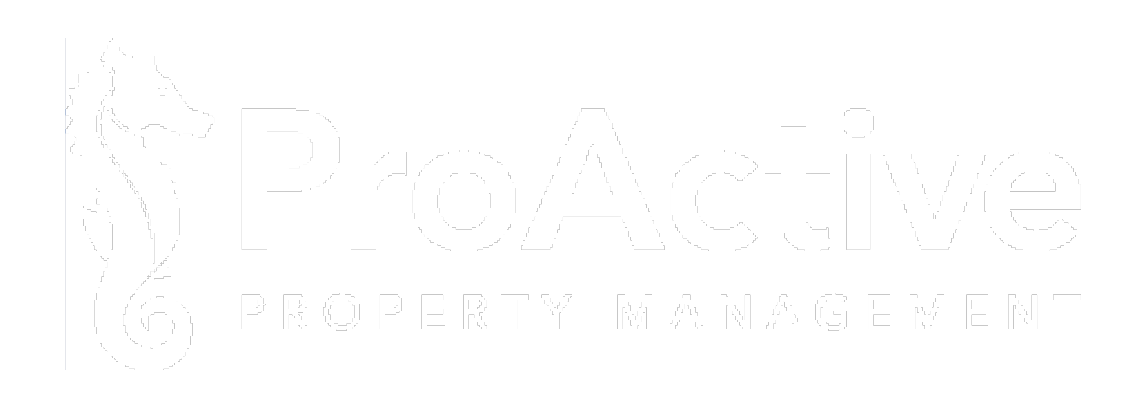

Dear Residents,
On behalf of ProActive Property Management, I would like to take a moment to formally introduce your designated Community Manager and Community Specialist.
Bea Jovel and Bree Rauck are your primary points of contact and are committed to supporting you and your community. Please feel free to reach out to them directly for assistance or questions.
  Bea Jovel  Community Specialist  Phone: 727-942-4755  E-Mail: bea@proactivefl.com  Support with:  - E-Mail and Phone Inquires  - Homeowner Online Portals  - Application Processing  - Architectural Modifications  - Access Items (Parking Passes, Gate Remotes, and Pool Keys) | Bree Rauck  Community Manager  Phone: 727-942-4755  E-Mail: bree@proactivefl.com  Support with:  - Annual and Budget Meetings  - Property Inspections  - Project Coordination  - Maintenance Requests

Accounts Receivable
If you have questions regarding account balances, payments, ACH, or late assessment notices (NOLA), you can contact our Accounts Receivable department at AR@proactivefl.com

Office Hours and Location
Should you need to visit our office, we are located at 4151 Woodlands Pkwy, Palm Harbor, FL 34685. Our office is open:

Monday – Thursday: 9am-5pm
Friday: 9am-1pm
You can also follow us online for seasonal and holiday reminders → 

We look forward to speaking with you.

